Removing one of the jawbones is a fairly simple process. Figures 3 through 6 show the steps involved. This process is safe even if you plan to have the deer head mounted. Taxidermists do not object to taking a deer head with a jawbone removed because it is not used in mounting.
1. To extract a jawbone, you need pruning shears and a jawbone puller. See Figure 2.
2. If the deer's jaw is locked shut, use the jawbone puller to pry open the mouth. See Figure 3.
3. Use the jawbone puller to loosen the muscles and membrane between the teeth and cheek by inserting the puller and twisting. See Figure 4.
4. Use the pruning shears to cut the jawbone. Insert the narrow side on the cheek side of the mouth. Be careful not to break the tops of the back teeth. See Figure 5.
5. After cutting the jawbone, insert the smaller, rounded end of the puller through the cut. With your fingers, push the back point of the lower jaw through the small end of the puller. See Figure 6.
6. Anchor the deer's head by placing your foot across the throat and give the puller a quick tug. The puller will slide along the bottom edge of the jawbone, breaking the connective tissue. Separate the two jawbones in the front where they meet.
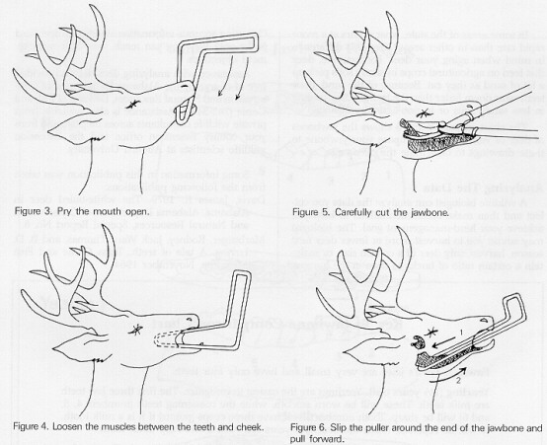
After you extract the jawbone, clean it by scraping away all muscle and tissue with the edge of a knife. Dry the jawbone with a cloth. Using a permanent marker, write the deer's identification number on the jawbone. Store the jaw in a dry, open place away from rain and where no animals can get it. A fish basket suspended from a rope in a shed is a good place.

